Supplement 1: Confusion matrix and ROC curve of the analysed models in the internal evaluation.
Figure 1. Normalised confusion matrix showing the multimodal AlexNet model across the haematolymphoid, neuroectodermal and neural crest-derived, mesenchymal, and melanocytic tumour groups.
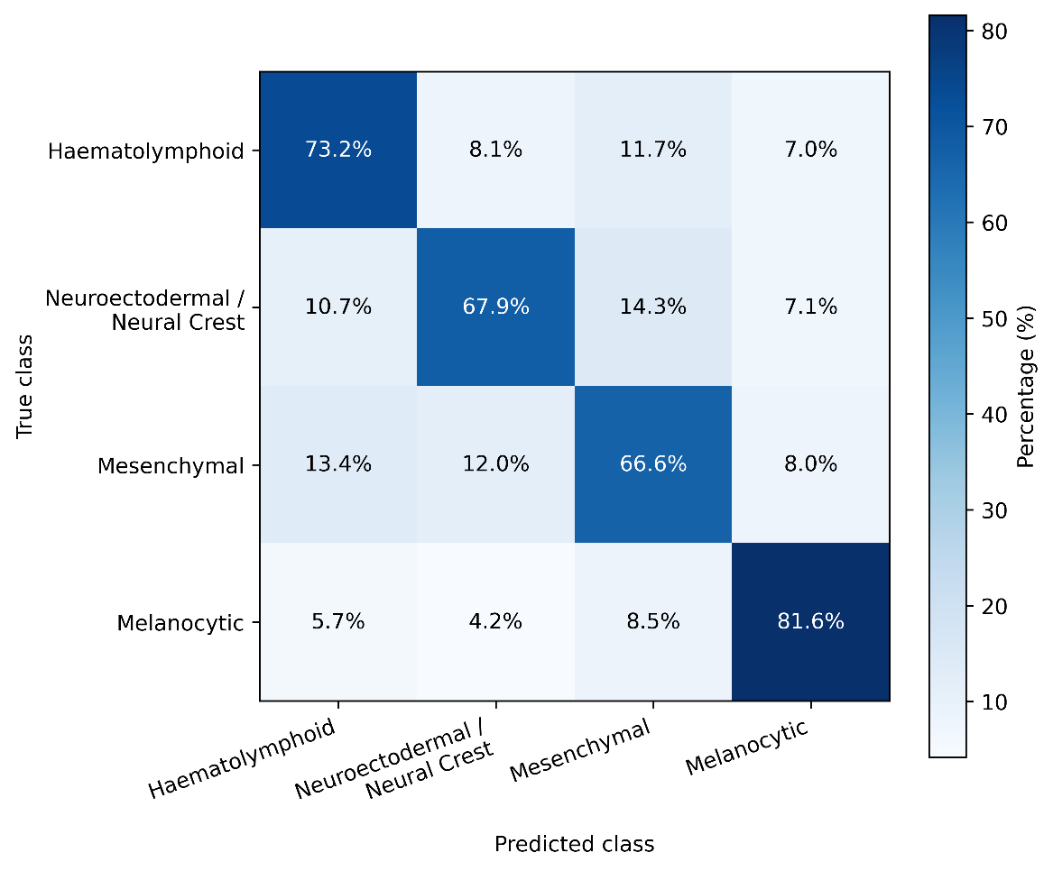
Figure 2. Receiver operating characteristic (ROC) curve of the multimodal AlexNet model.
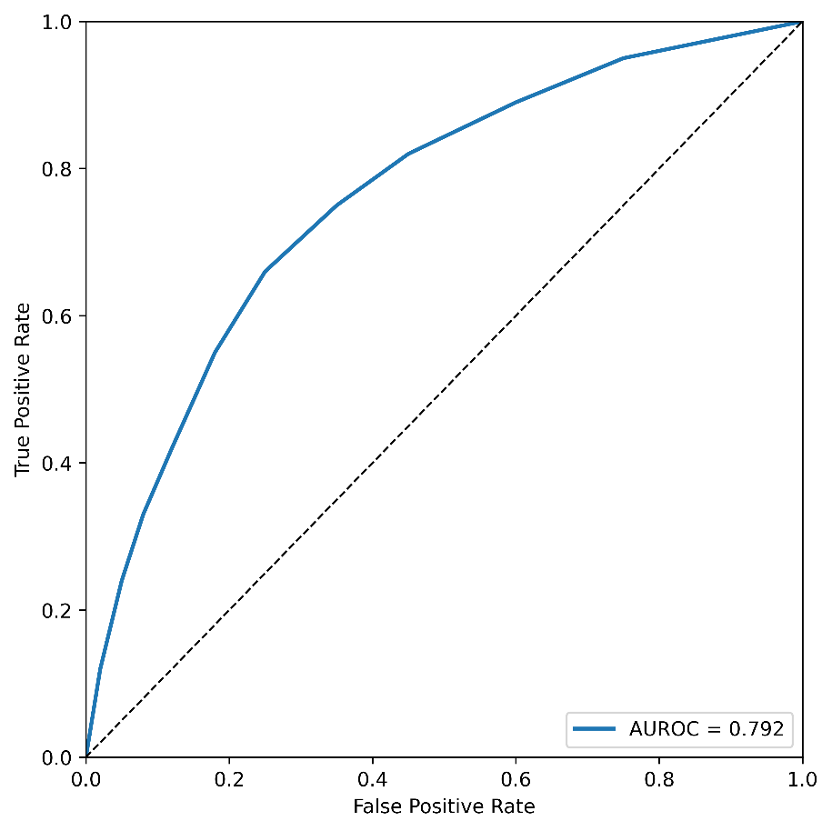
Figure 3. Normalised confusion matrix showing the multimodal MobileNet model across the haematolymphoid, neuroectodermal and neural crest-derived, mesenchymal, and melanocytic tumour groups.
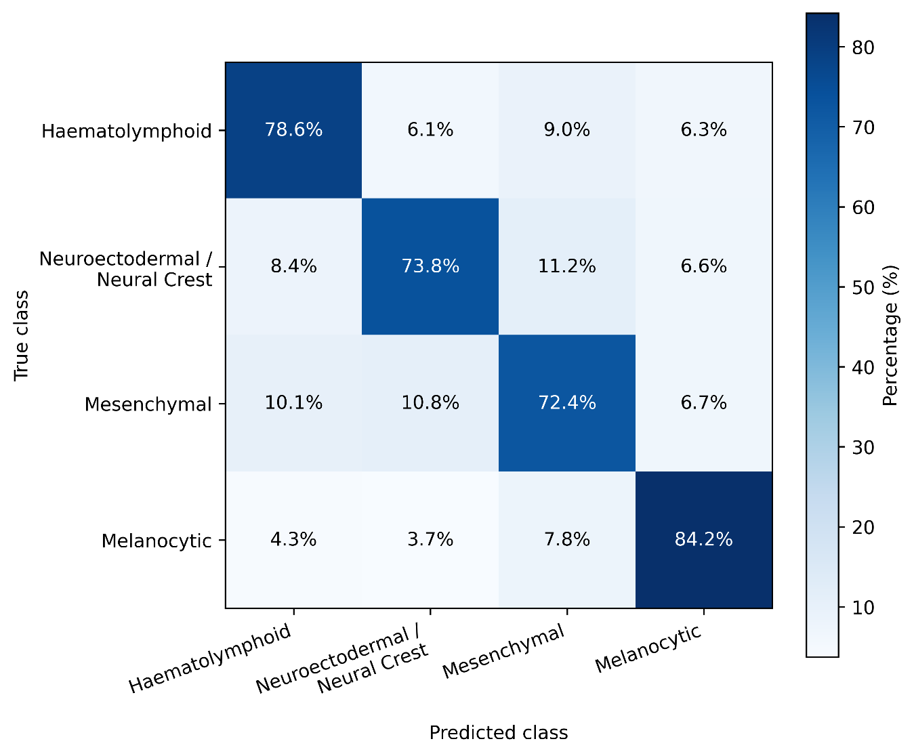
Figure 4. Receiver operating characteristic (ROC) curve of the multimodal MobileNet model.
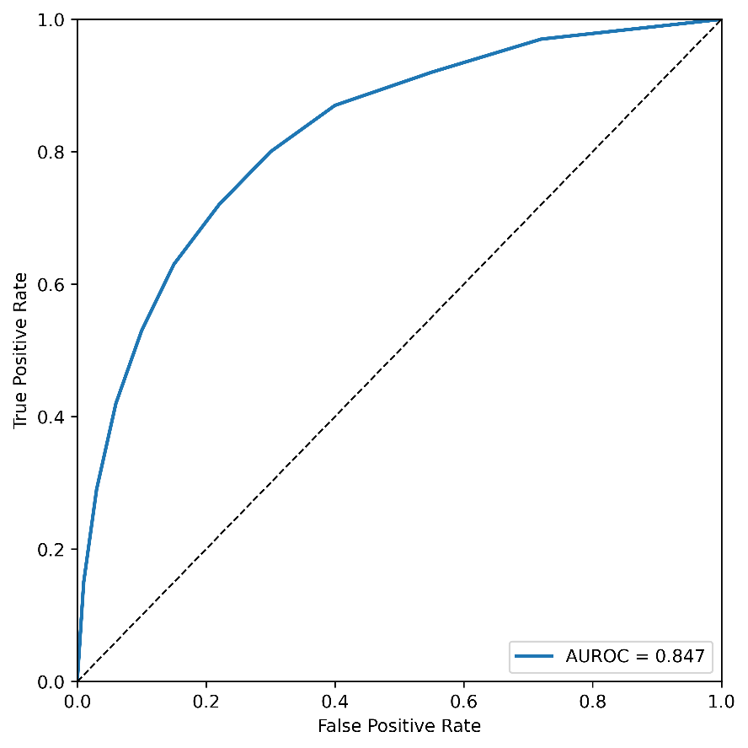
Figure 5. Normalised confusion matrix showing the multimodal InceptionV3 model across the haematolymphoid, neuroectodermal and neural crest-derived, mesenchymal, and melanocytic tumour groups.
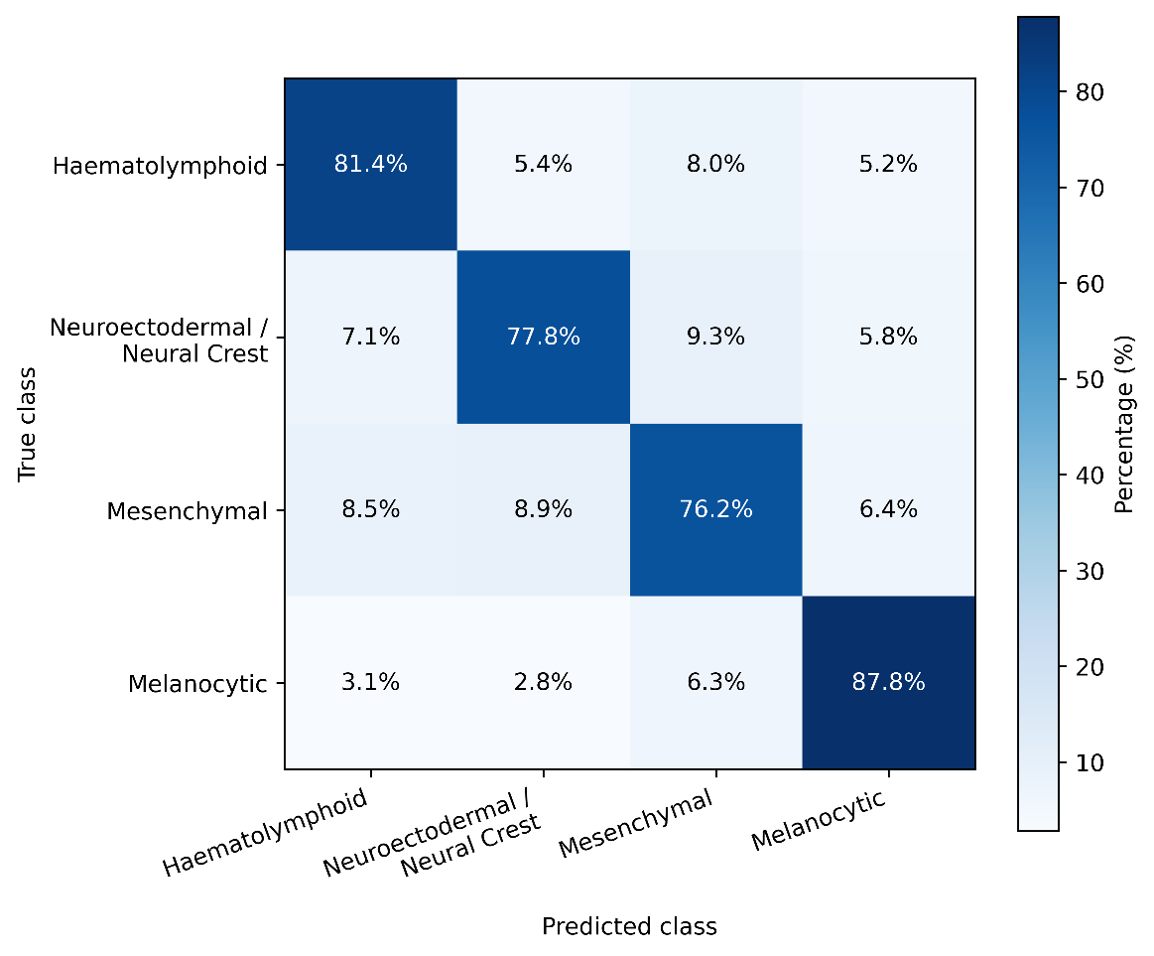
Figure 6. Receiver operating characteristic (ROC) curve of the multimodal InceptionV3 model.
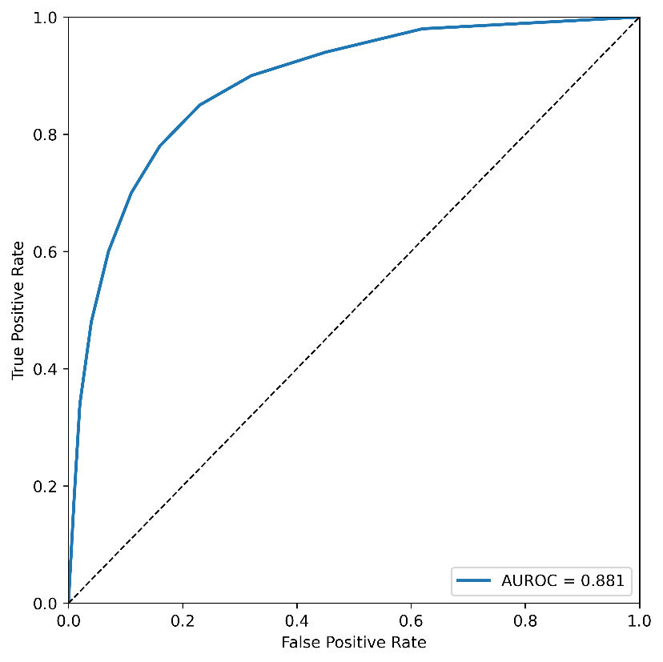
Figure 7. Normalised confusion matrix showing the multimodal DenseNet121 model across the haematolymphoid, neuroectodermal and neural crest-derived, mesenchymal, and melanocytic tumour groups.
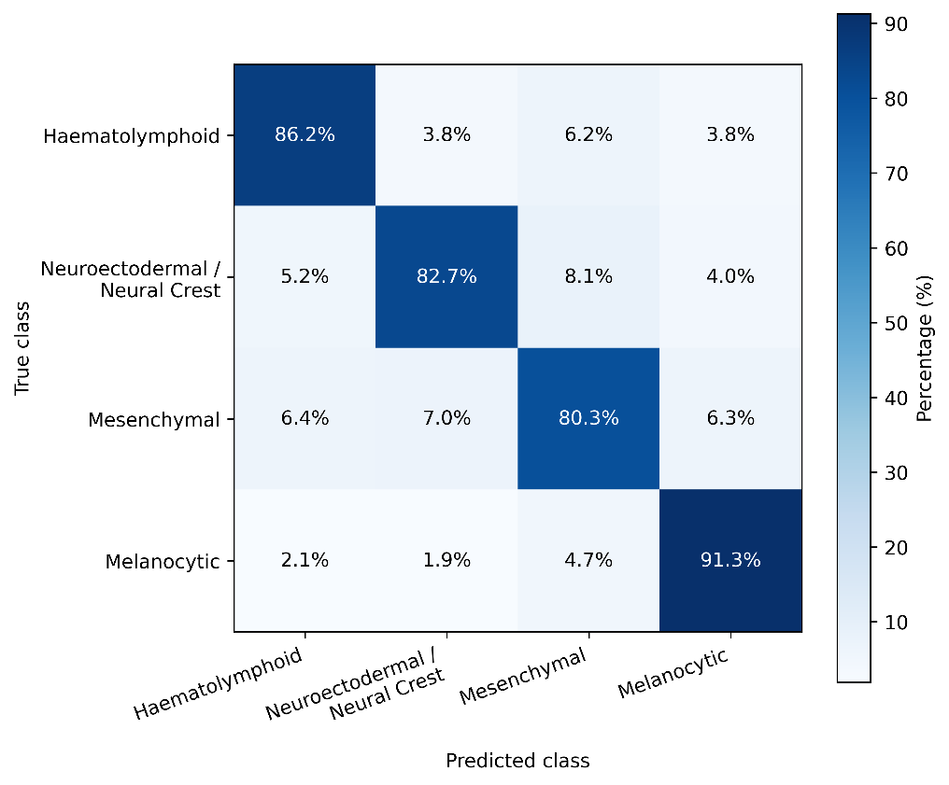
Figure 8. Receiver operating characteristic (ROC) curve of the multimodal DenseNet121 model.
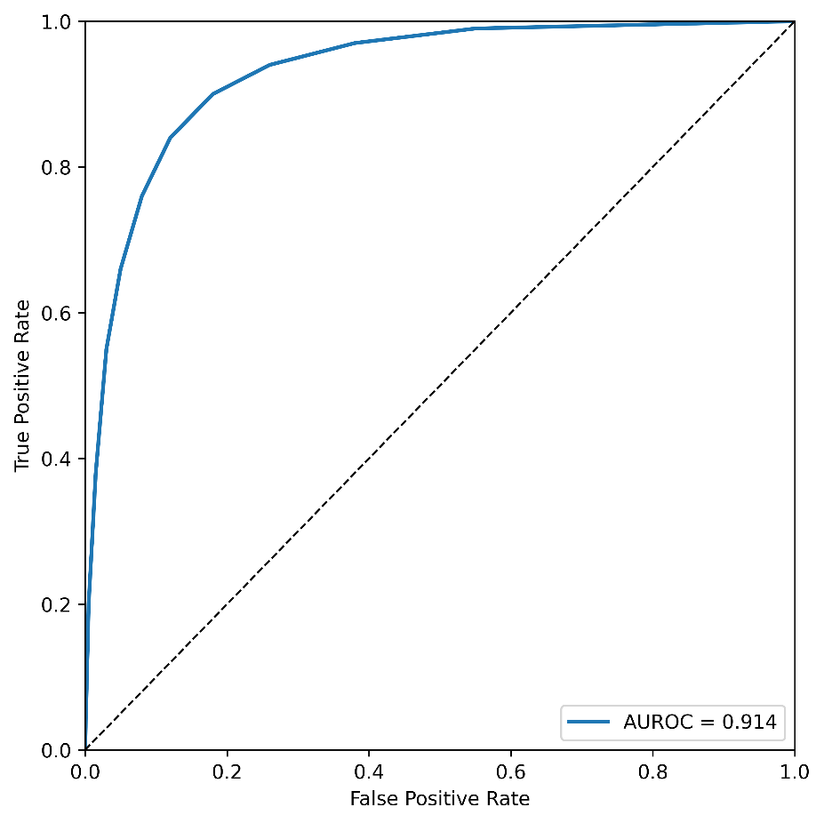
Figure 9. Normalised confusion matrix showing the multimodal Xception model across the haematolymphoid, neuroectodermal and neural crest-derived, mesenchymal, and melanocytic tumour groups.
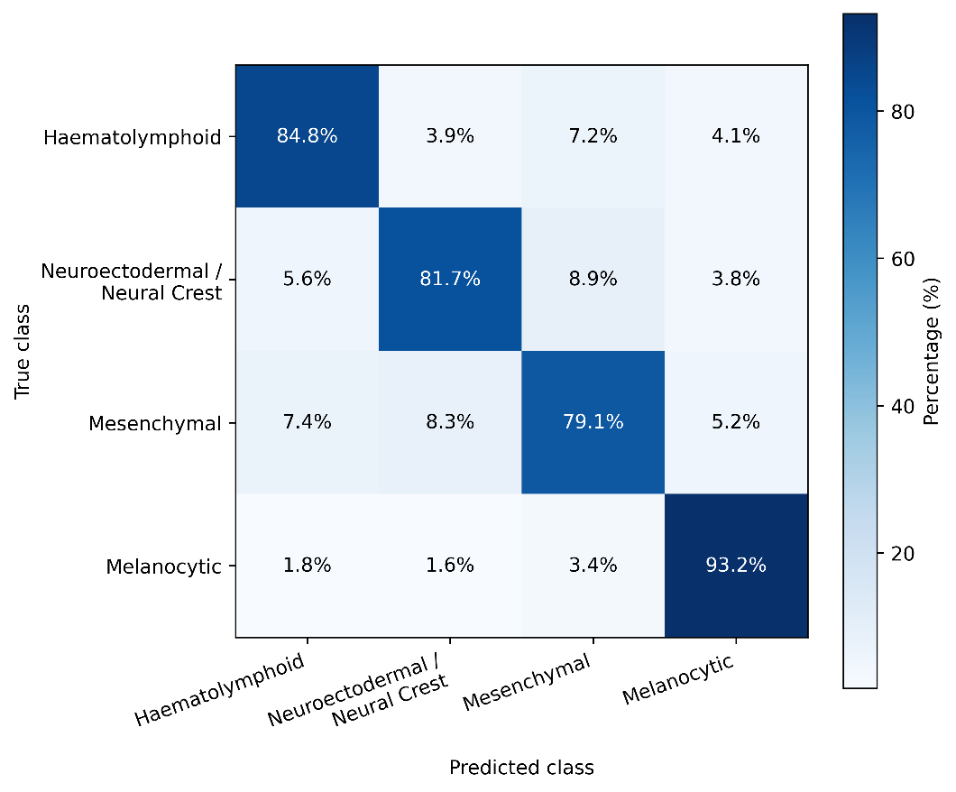
Figure 10. Receiver operating characteristic (ROC) curve of the multimodal Xception model.
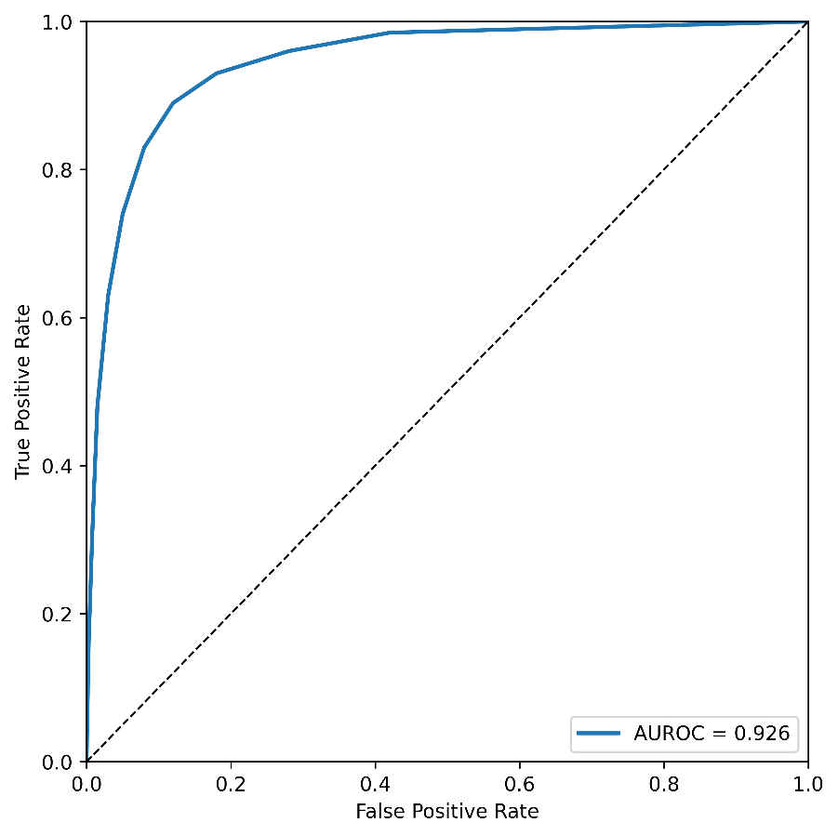
Figure 11. Normalised confusion matrix showing the multimodal ResNet50 model across the haematolymphoid, neuroectodermal and neural crest-derived, mesenchymal, and melanocytic tumour groups.
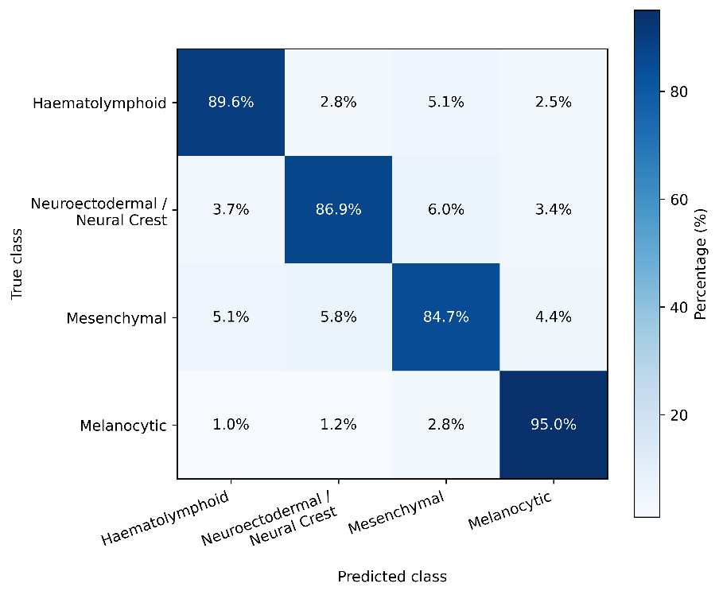
Figure 12. Receiver operating characteristic (ROC) curve of the multimodal ResNet50 model.
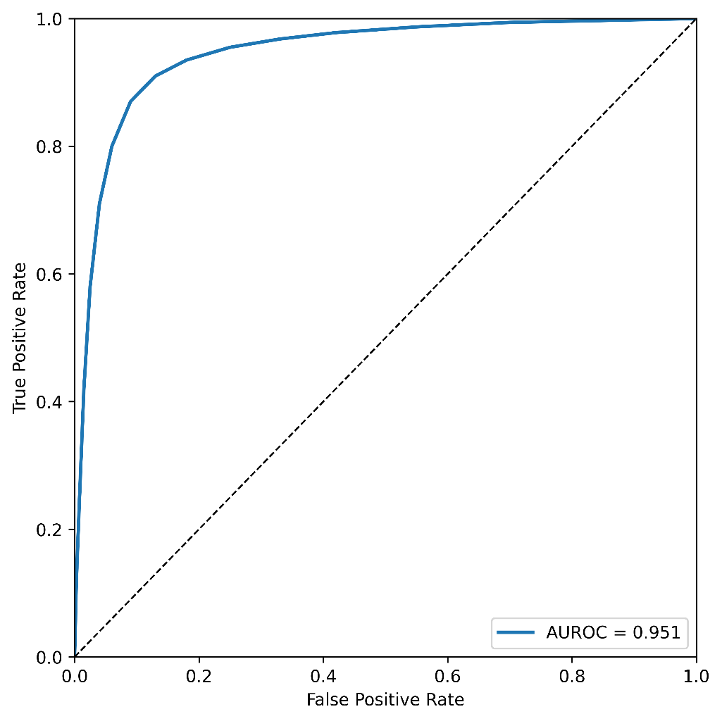
Figure 13. Normalised confusion matrix showing the multimodal CellViT++ model across the haematolymphoid, neuroectodermal and neural crest-derived, mesenchymal, and melanocytic tumour groups.
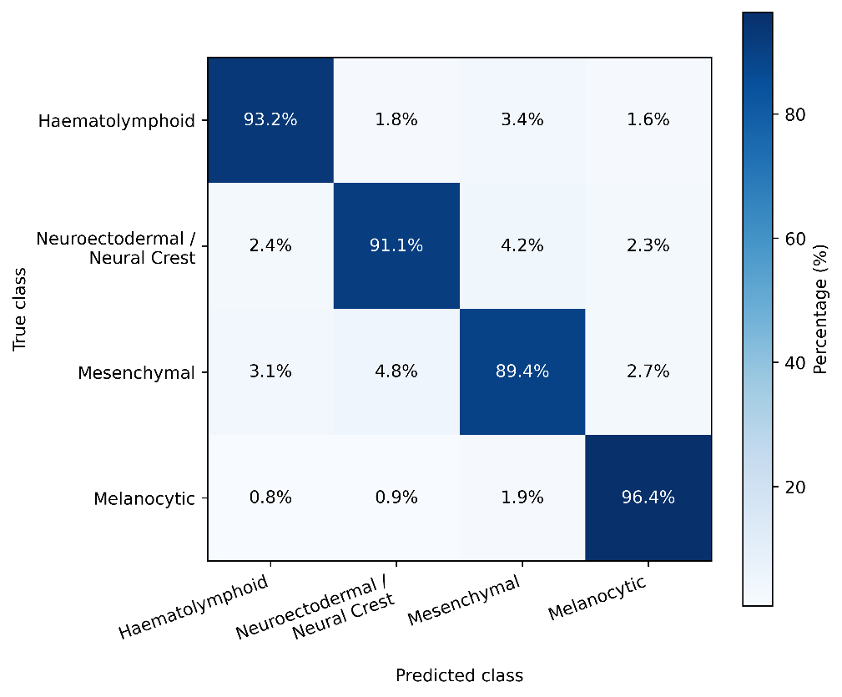
Figure 14. Receiver operating characteristic (ROC) curve of the multimodal CellViT++ model.
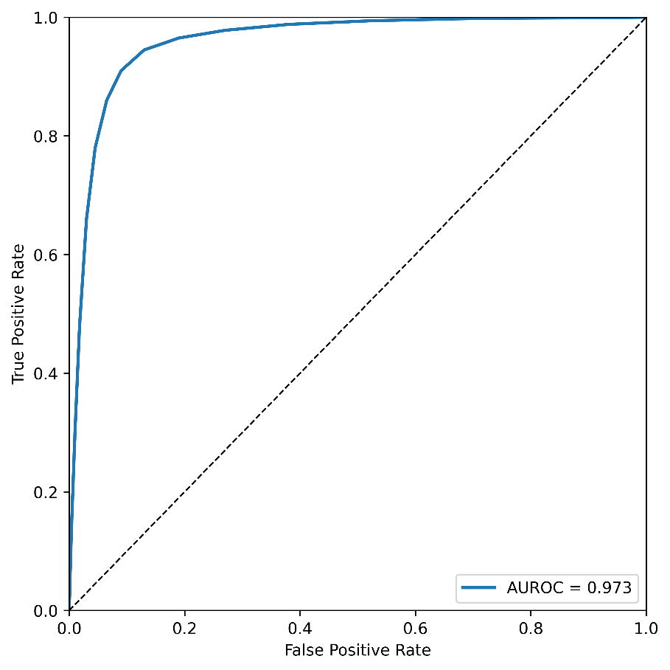
Figure 15. Normalised confusion matrix showing UNI model across the haematolymphoid, neuroectodermal and neural crest-derived, mesenchymal, and melanocytic tumour groups.
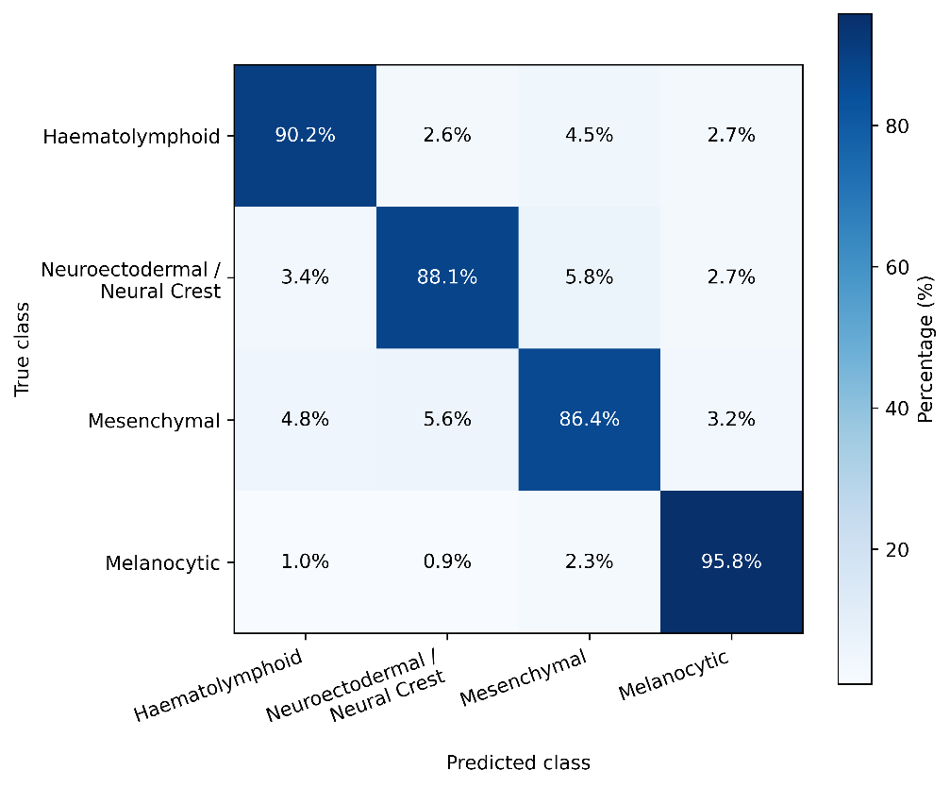
Figure 16. Receiver operating characteristic (ROC) curve of the UNI model.
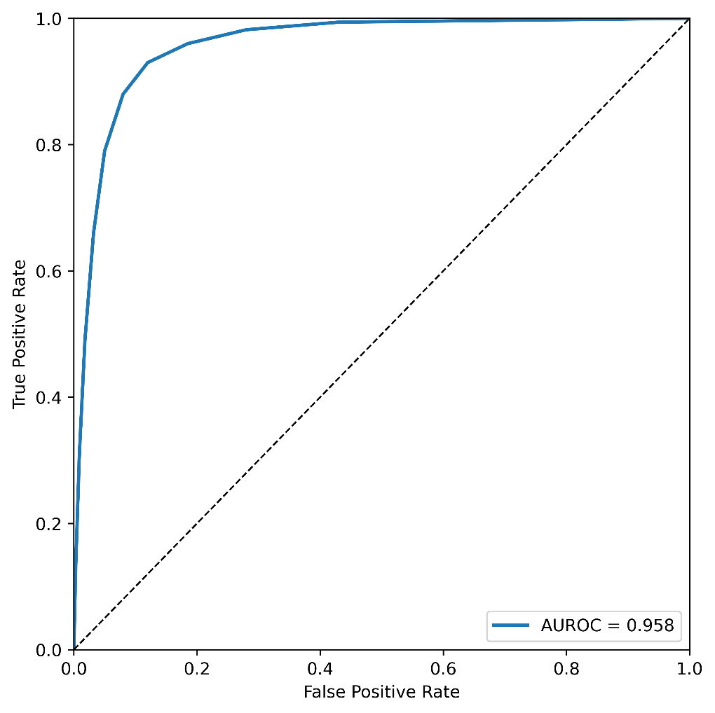
Figure 17. Normalised confusion matrix showing Virchow model across the haematolymphoid, neuroectodermal and neural crest-derived, mesenchymal, and melanocytic tumour groups.
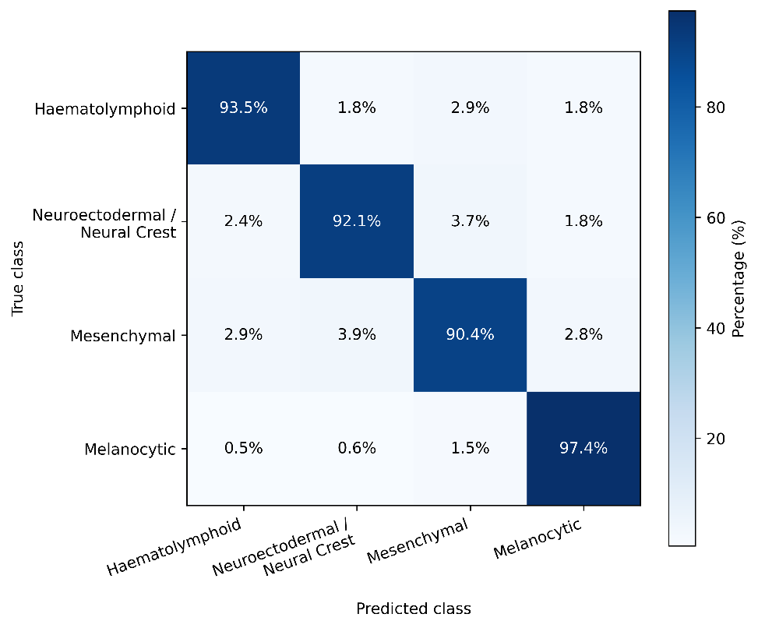
Figure 18. Receiver operating characteristic (ROC) curve of the Virchow model.
